System Design Documentation

Project Title:
Design and Development of a Rule-Based AI-Powered Student Productivity and Academic Scheduling System

1. UML Diagrams

1.1 Use Case Diagram
The Use Case Diagram illustrates the functional requirements of the system and the interactions between the student and the system functionalities such as task management, availability input, and schedule generation.
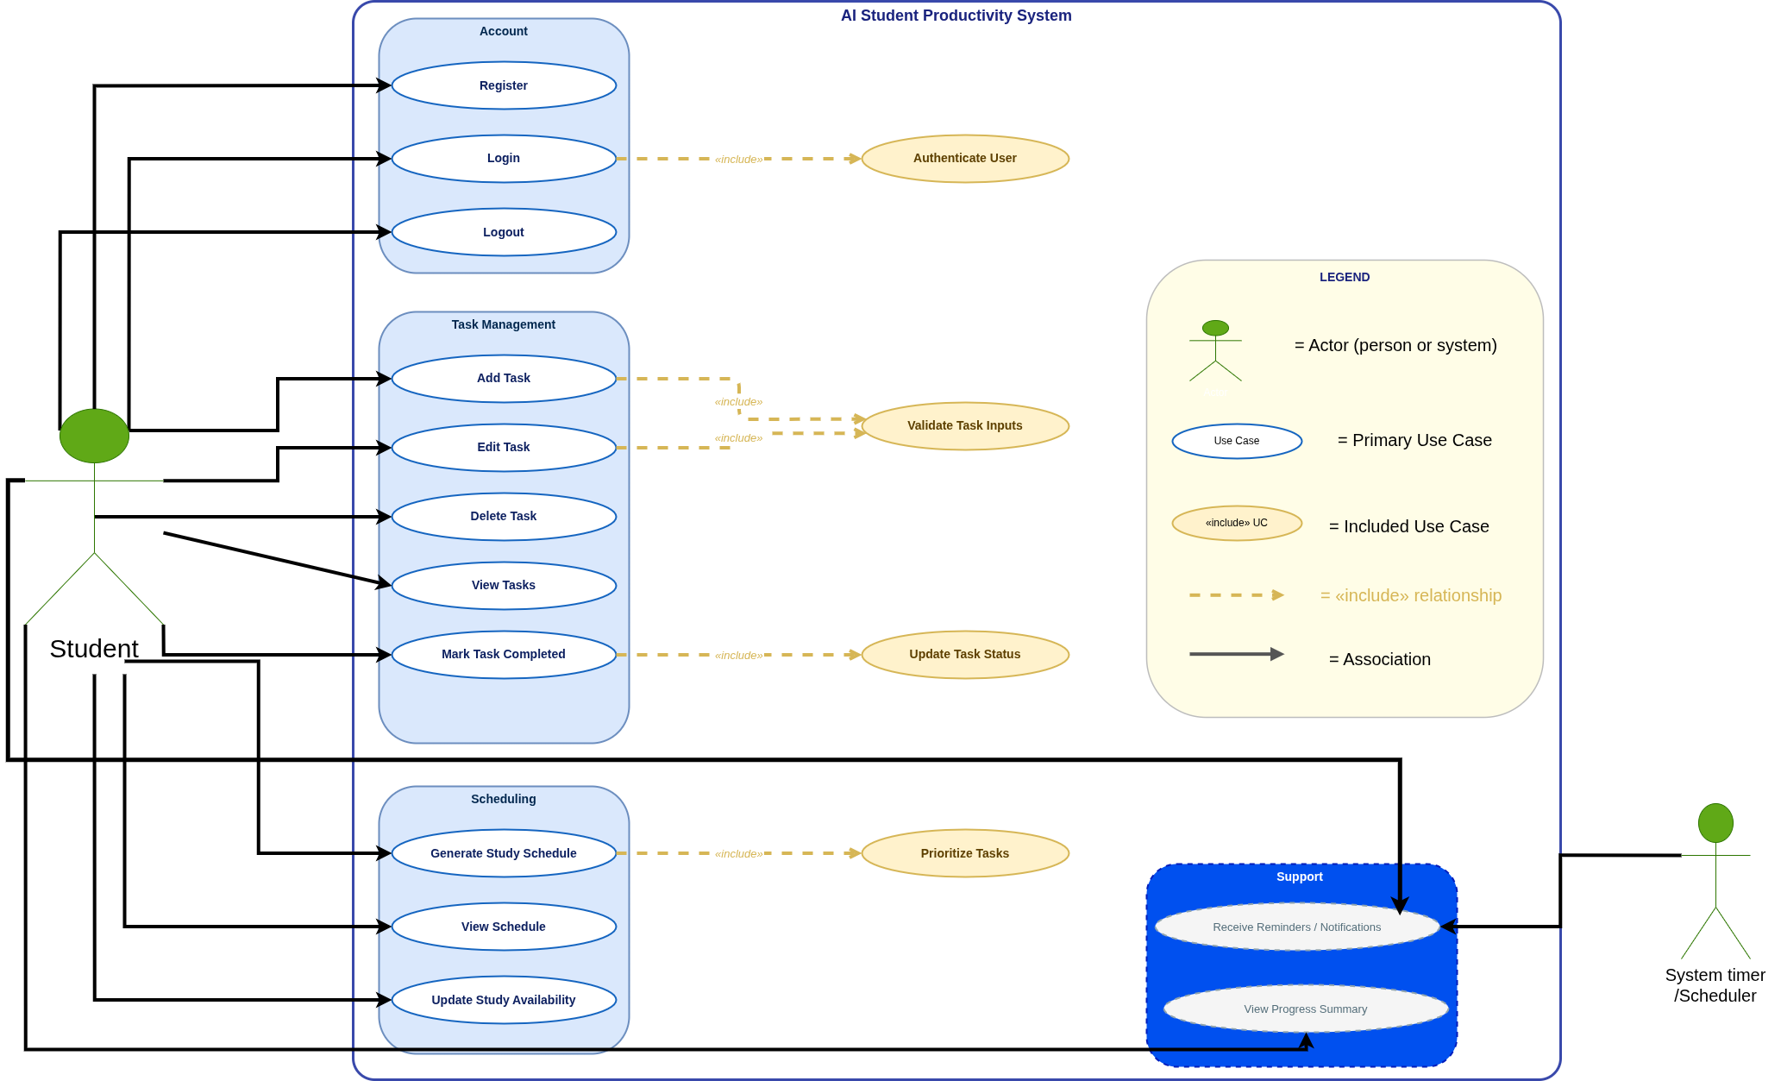
Figure 1: Use Case Diagram

1.2 Activity Diagram
The Activity Diagram models the workflow involved in automatic schedule generation. The system retrieves pending tasks and available study time before applying rule-based prioritization logic to allocate study sessions.
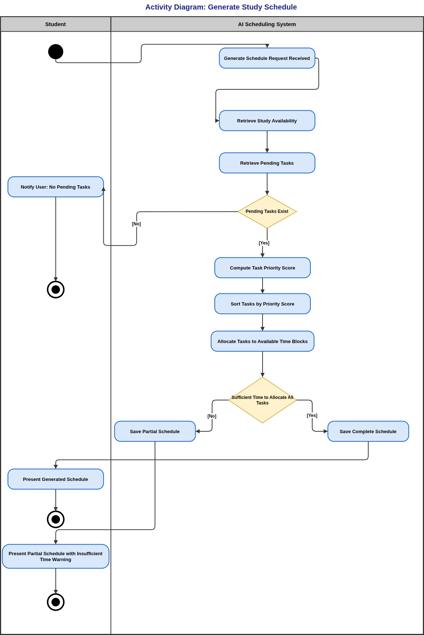
Figure 2: Schedule Generation Activity Diagram

1.3 Sequence Diagram
The Sequence Diagram illustrates the interaction between system components during schedule generation including communication between the Scheduling Module and the PriorityRuleEngine.
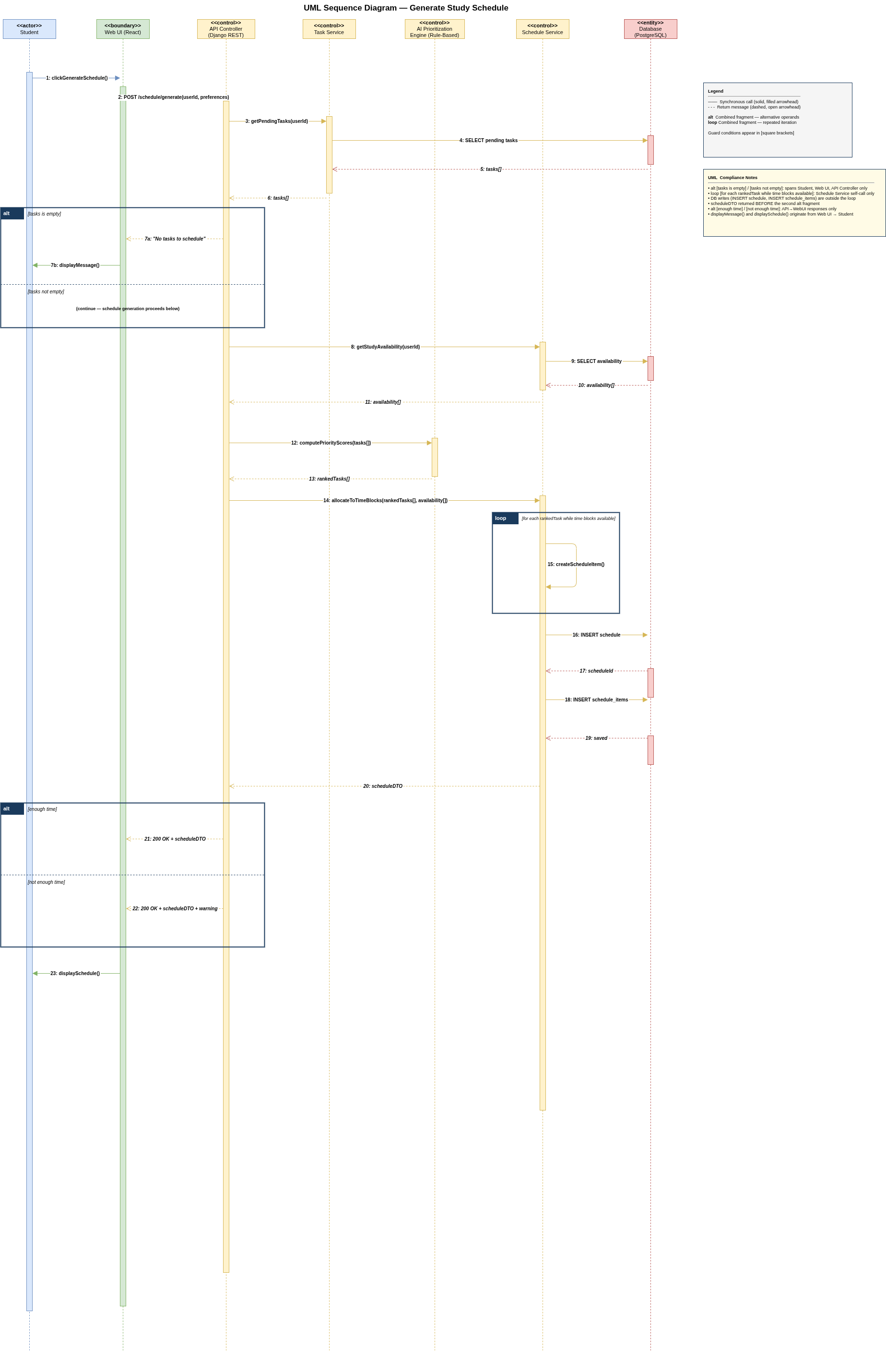
Figure 3: Schedule Generation Sequence Diagram

1.4 Class Diagram
The Class Diagram represents the structural design of the system by defining its core entities including User, Task, StudyAvailability, Schedule, and ScheduleItem.
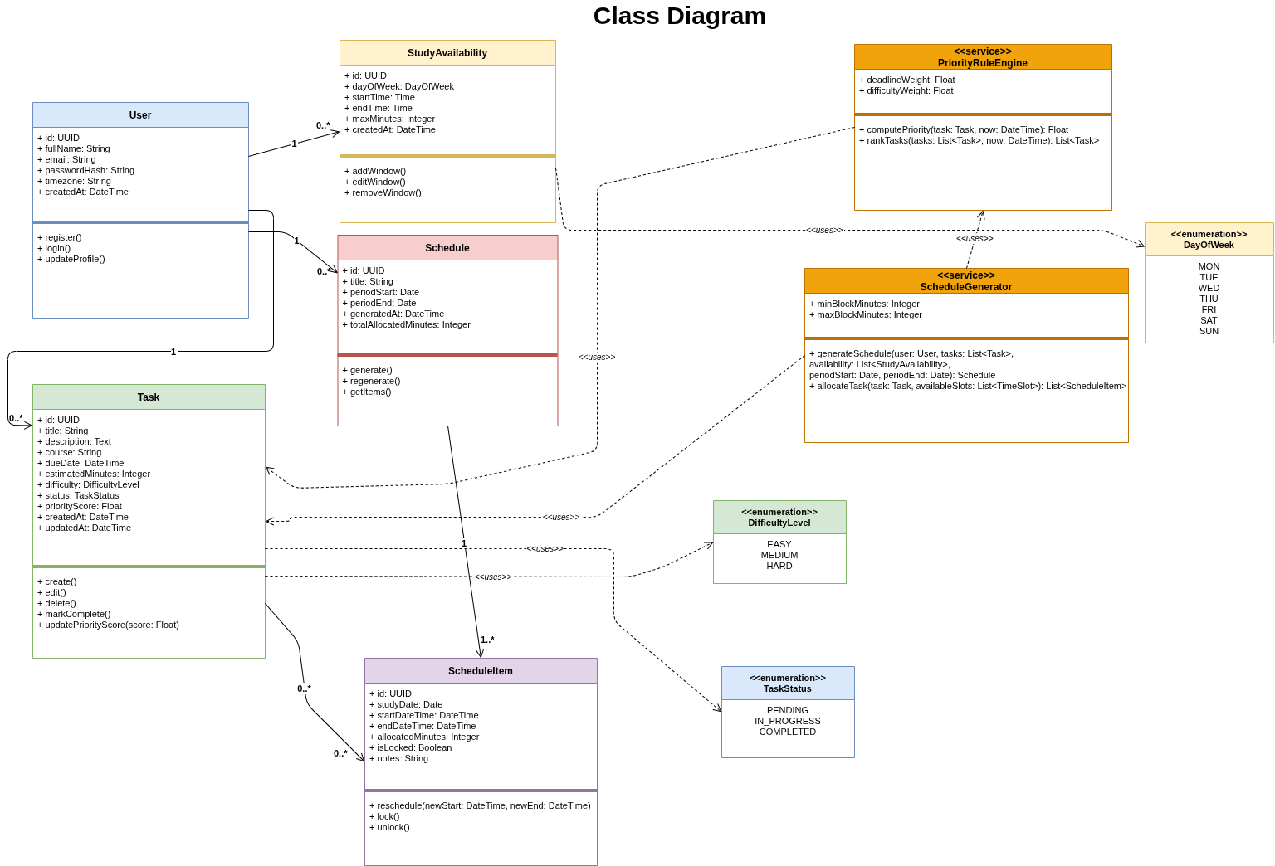
Figure 4: Class Diagram

1.5 Component Diagram
The Component Diagram illustrates the system architecture as a three-tier web-based application consisting of a React client layer, a Django REST backend layer, and a PostgreSQL database layer.
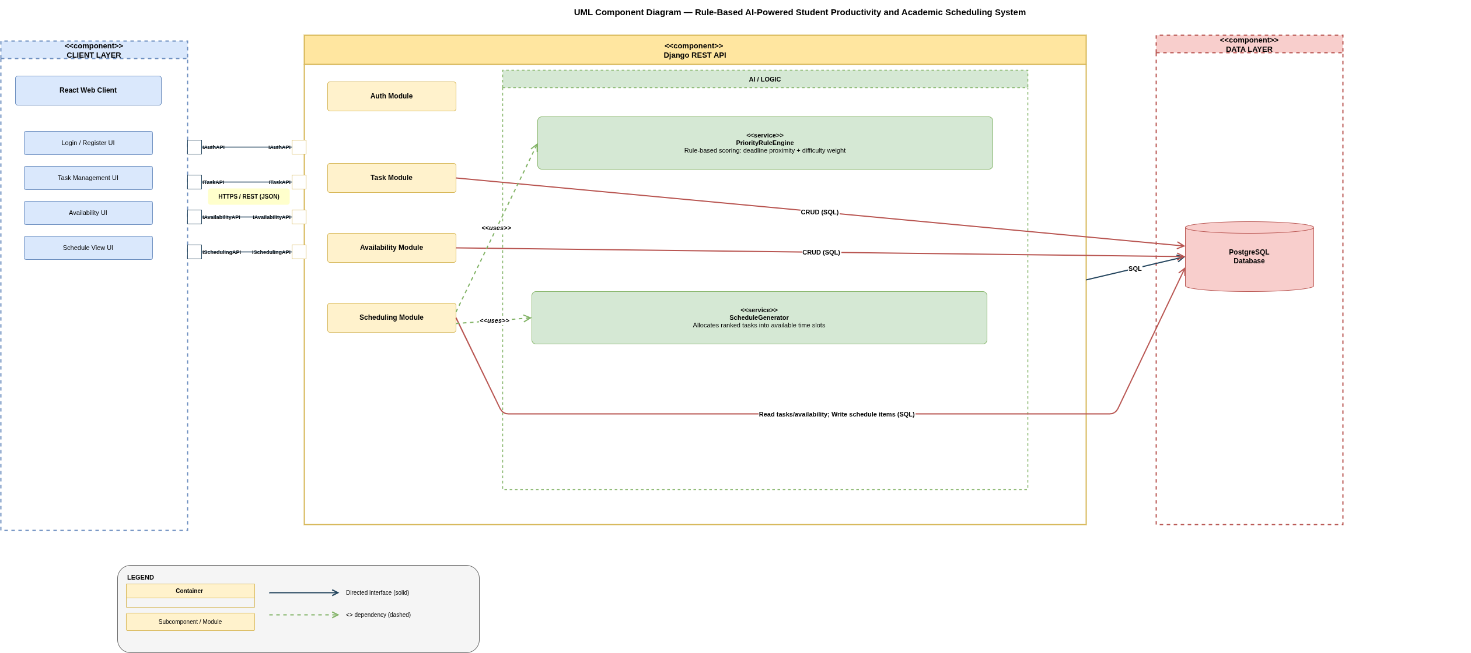
Figure 5: System Component Diagram

2. User Interface Design (Figma)
Low-fidelity wireframes were created using Figma to represent key system interfaces for task management, availability input, and schedule generation.
The Login Interface allows students to access the system securely using their registered email and password.
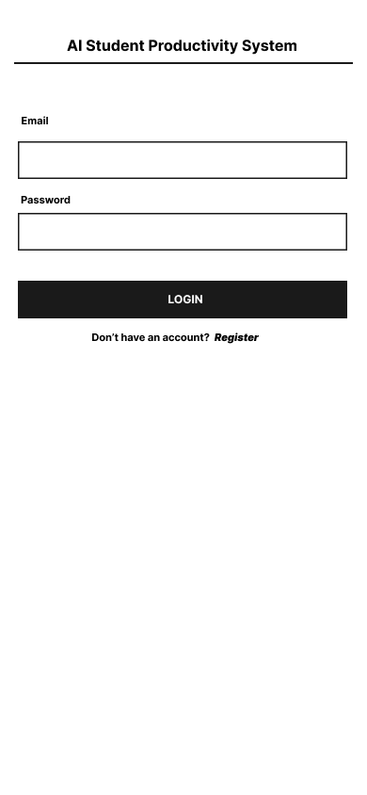
[
Figure 6: Login Interface
The Registration Interface allows new users to create an account within the system.
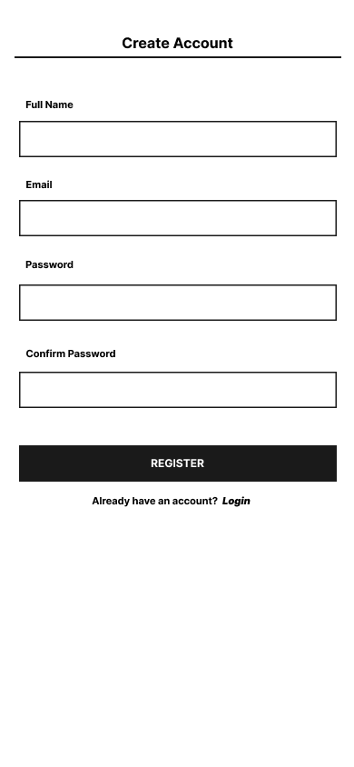
Figure 7: Registration Interface
The Dashboard Interface provides an overview of tasks and scheduling information.
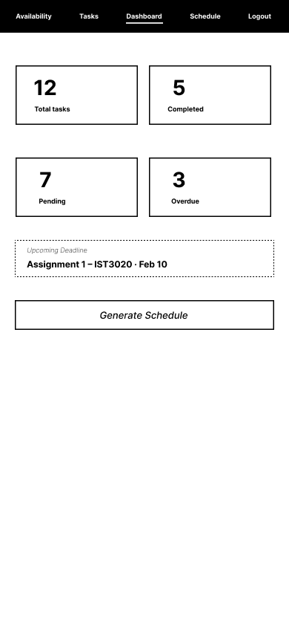
Figure 8: Dashboard Interface
The Task Management Interface allows users to create, edit, delete, and update tasks.
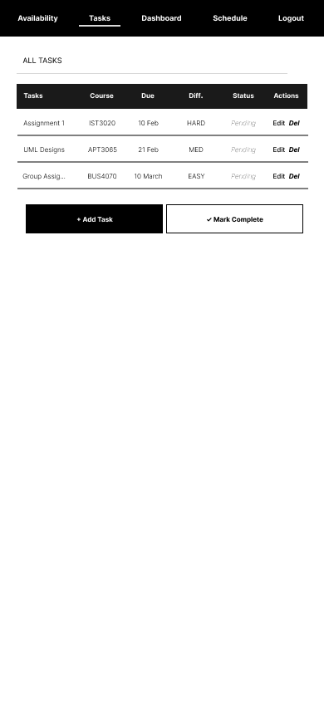
Figure 9: Task Management Interface
The Study Availability Interface allows users to define available study time windows.
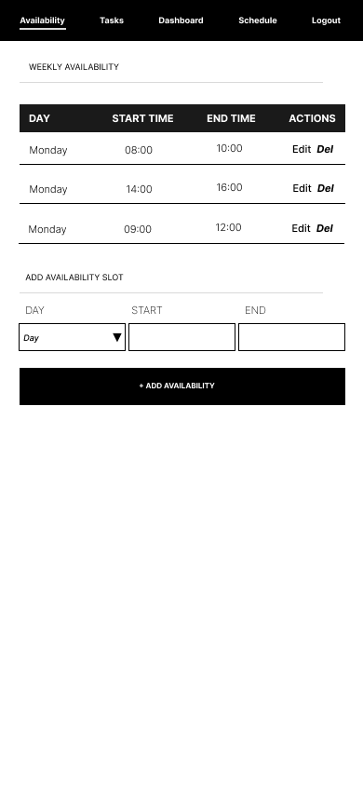
Figure 10: Study Availability Interface
The Schedule Generation Interface allows users to initiate automatic schedule generation.
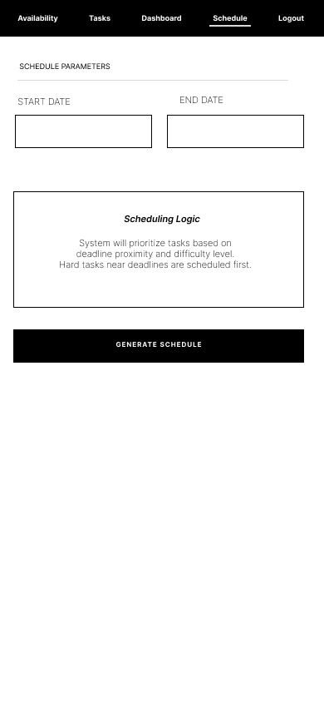
Figure 11: Schedule Generation Interface
The Schedule View Interface displays the generated study schedule to the user.
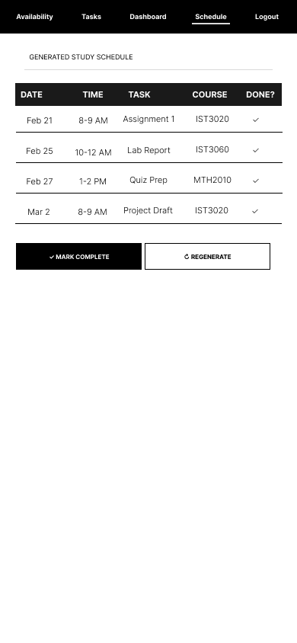
Figure 12: Schedule View Interface
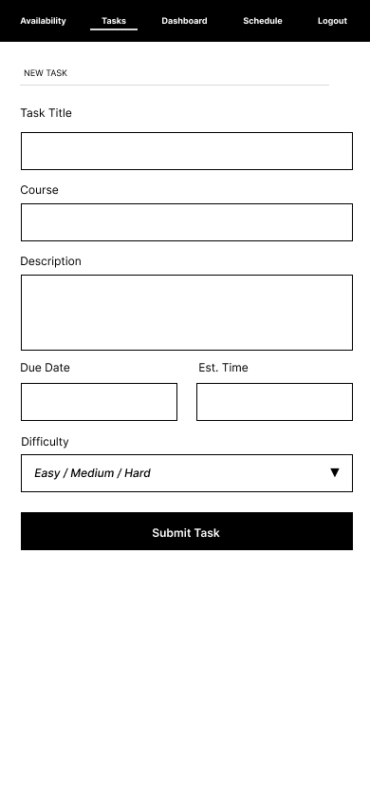
Figure 13: Add Tasks Interface

3. Database Design
The system database was implemented using PostgreSQL and structured around five core tables namely users, tasks, study_availability, schedules, and schedule_items.

3.1 Data Dictionary
Table 1: Users Table Data Dictionary
Field Name | Data Type | Size | Description | Constraint | Default Value
id | UUID | - | Unique user identifier | Primary Key | Auto Generated
full_name | VARCHAR | 120 | Student full name | NOT NULL | -
email | VARCHAR | 254 | User email address | UNIQUE | -
password_hash | TEXT | - | Encrypted password | NOT NULL | -
timezone | VARCHAR | 64 | User timezone | NULL | -
created_at | TIMESTAMP | - | Account creation date | NOT NULL | CURRENT_TIMESTAMP
The Users table stores student account information.
Table 2: Tasks Table Data Dictionary
Field Name | Data Type | Size | Description | Constraint | Default Value
id | UUID | - | Unique task identifier | Primary Key | Auto Generated
user_id | UUID | - | Associated user | Foreign Key | -
title | VARCHAR | 200 | Task title | NOT NULL | -
description | TEXT | - | Task details | NULL | -
course | VARCHAR | 120 | Course name | NOT NULL | -
due_date | TIMESTAMP | - | Task deadline | NOT NULL | -
estimated_minutes | INTEGER | - | Estimated duration | NOT NULL | -
difficulty | VARCHAR | 10 | Task difficulty | CHECK | -
status | VARCHAR | 15 | Task status | CHECK | -
priority_score | FLOAT | - | Computed priority score | DEFAULT | 0
The Tasks table stores academic tasks created by users.
Table 3: Study Availability Table Data Dictionary
Field Name | Data Type | Size | Description | Constraint | Default Value
id | UUID | - | Availability identifier | Primary Key | Auto Generated
user_id | UUID | - | Associated user | Foreign Key | -
day_of_week | VARCHAR | 3 | Day of availability | NOT NULL | -
start_time | TIME | - | Start time | NOT NULL | -
end_time | TIME | - | End time | NOT NULL | -
created_at | TIMESTAMP | - | Creation timestamp | NOT NULL | CURRENT_TIMESTAMP
The Study Availability table stores user-defined study time windows.
Table 4: Schedule Table Data Dictionary
Field Name | Data Type | Size | Description | Constraint | Default Value
id | UUID | - | Schedule identifier | Primary Key | Auto Generated
user_id | UUID | - | Associated user | Foreign Key | -
title | VARCHAR | 120 | Schedule title | NOT NULL | -
period_start | DATE | - | Start of schedule period | NOT NULL | -
period_end | DATE | - | End of schedule period | NOT NULL | -
generated_at | TIMESTAMP | - | Generation time | NOT NULL | CURRENT_TIMESTAMP
total_allocated_minutes | INTEGER | - | Allocated time | DEFAULT | 0
The Schedule table stores generated study schedules.
Table 5: Schedule Items Table Data Dictionary
Field Name | Data Type | Size | Description | Constraint | Default Value
id | UUID | - | Schedule item identifier | Primary Key | Auto Generated
schedule_id | UUID | - | Associated schedule | Foreign Key | -
task_id | UUID | - | Associated task | Foreign Key | -
study_date | DATE | - | Scheduled date | NOT NULL | -
start_datetime | TIMESTAMP | - | Start date and time | NOT NULL | -
end_datetime | TIMESTAMP | - | End date and time | NOT NULL | -
allocated_minutes | INTEGER | - | Allocated duration | NOT NULL | -
is_locked | BOOLEAN | - | Lock status | DEFAULT | FALSE
notes | VARCHAR | 255 | Optional notes | NULL | -
The Schedule Items table stores allocated study sessions.

4. API Design
The system exposes RESTful API endpoints implemented using Django REST Framework to support communication between the React client interface and backend services.
Table 6: API Endpoint Design
Endpoint | Method | Description | Request Parameters | Response
/api/auth/register | POST | Register new user | fullName, email, password | Success message
/api/auth/login | POST | User login | email, password | Access token
/api/tasks | POST | Create new task | title, description, course, dueDate, estimatedMinutes, difficulty | Task object
/api/tasks | GET | Retrieve all tasks | userId | List of tasks
/api/tasks/{id} | PUT | Update task | title, dueDate, difficulty | Updated task
/api/tasks/{id} | DELETE | Delete task | taskId | Success message
/api/tasks/{id}/complete | PATCH | Mark task complete | taskId | Updated status
/api/availability | POST | Add study availability | dayOfWeek, startTime, endTime | Availability object
/api/availability | GET | Retrieve availability | userId | List of availability
/api/availability/{id} | PUT | Update availability | startTime, endTime | Updated availability
/api/availability/{id} | DELETE | Remove availability | availabilityId | Success message
/api/schedule/generate | POST | Generate study schedule | userId, periodStart, periodEnd | Schedule object
/api/schedule | GET | View generated schedule | userId | Schedule list
/api/schedule/{id} | GET | View schedule items | scheduleId | ScheduleItem list

5. Rule-Based Task Prioritization Logic
Task prioritization is computed using a deterministic rule-based weighted scoring approach that considers deadline proximity and task difficulty level.
Priority Score = (Deadline Weight × Deadline Proximity) + (Difficulty Weight × Task Difficulty)

6. Schedule Generation Process
Once tasks are prioritized, the ScheduleGenerator allocates study sessions into user-defined availability windows while ensuring that scheduled sessions do not overlap.

Screenshots
1.
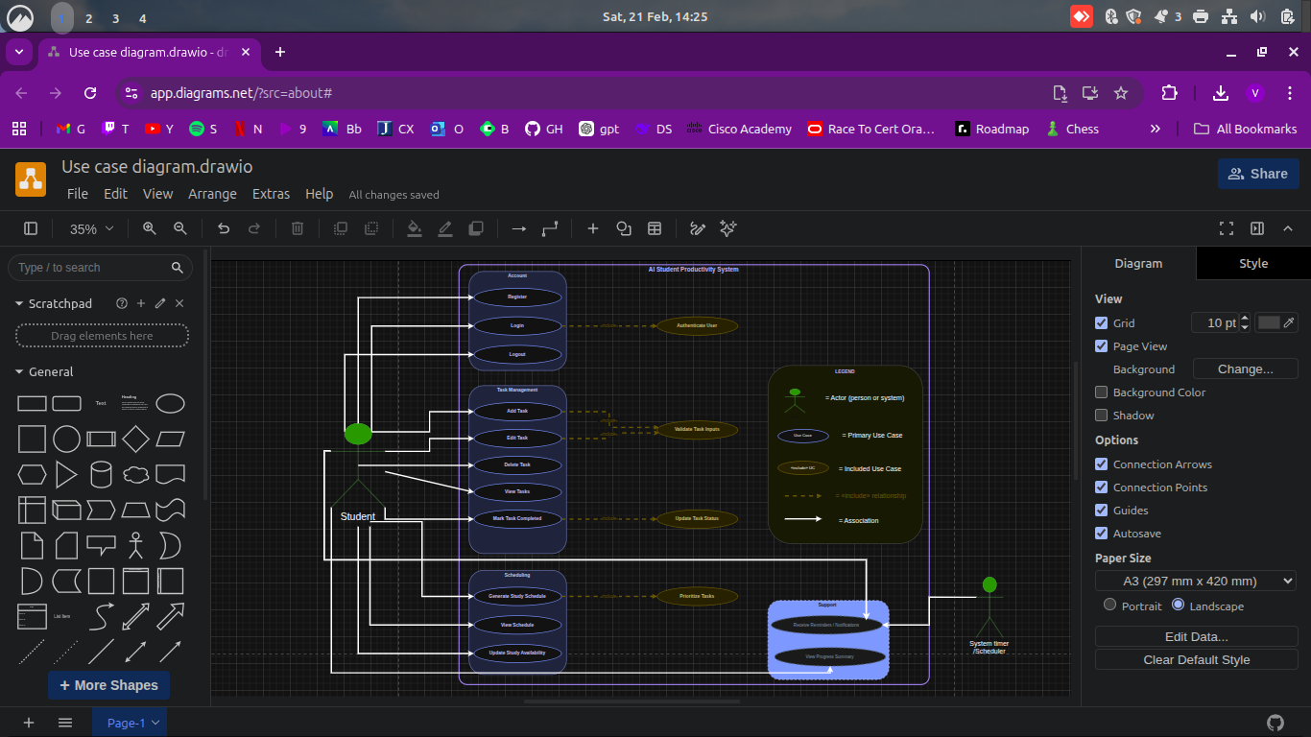
2.
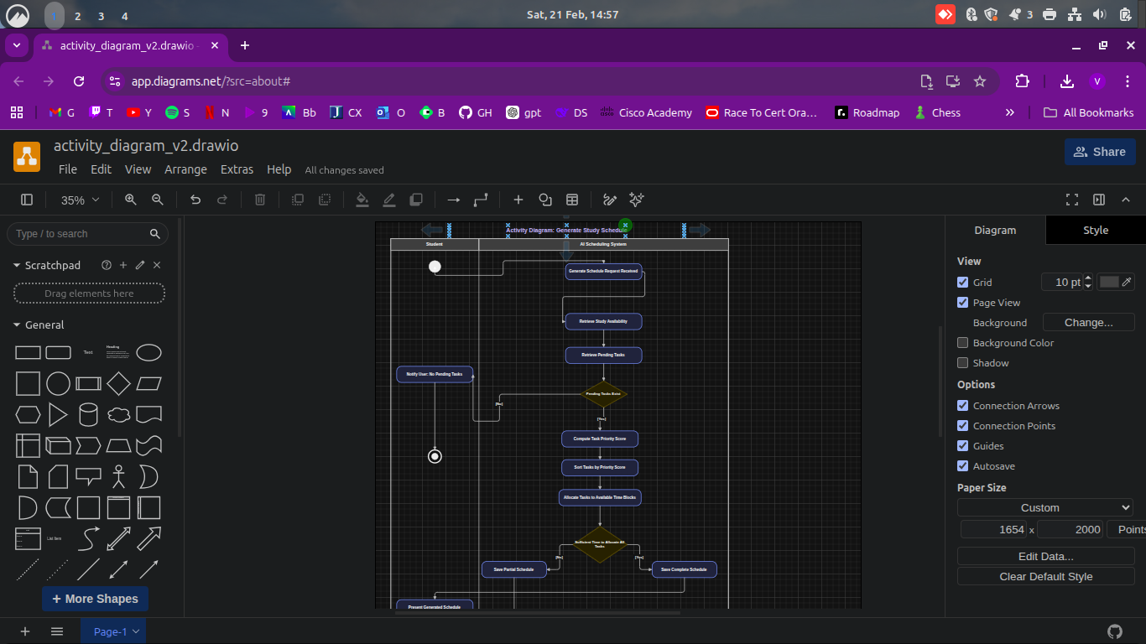
3.
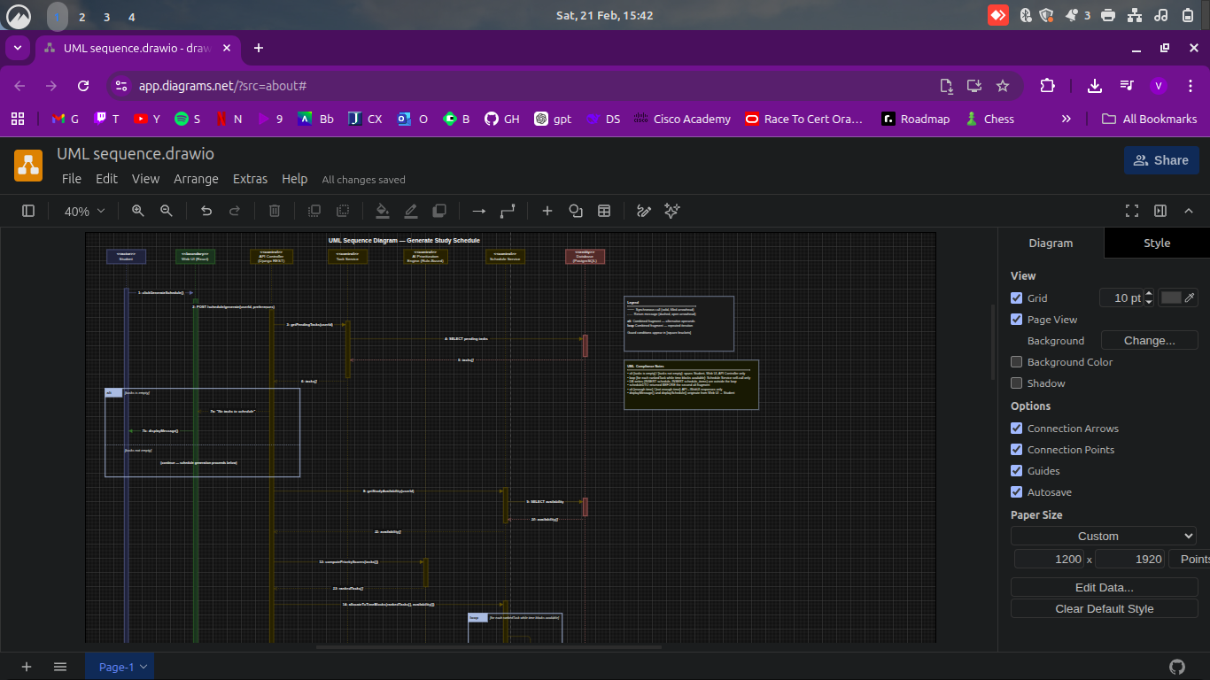
4.
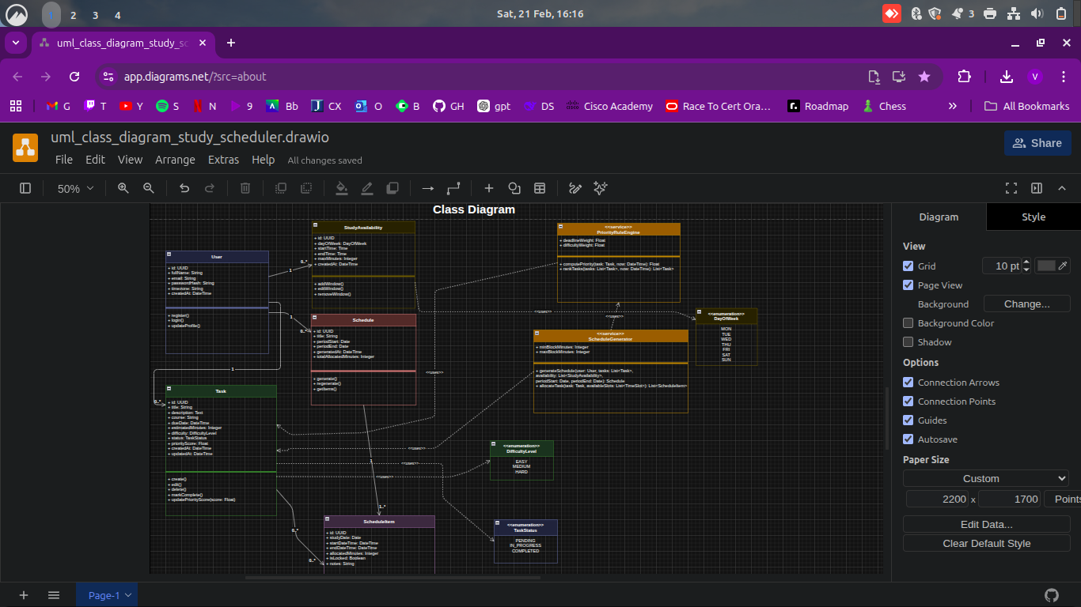
5.
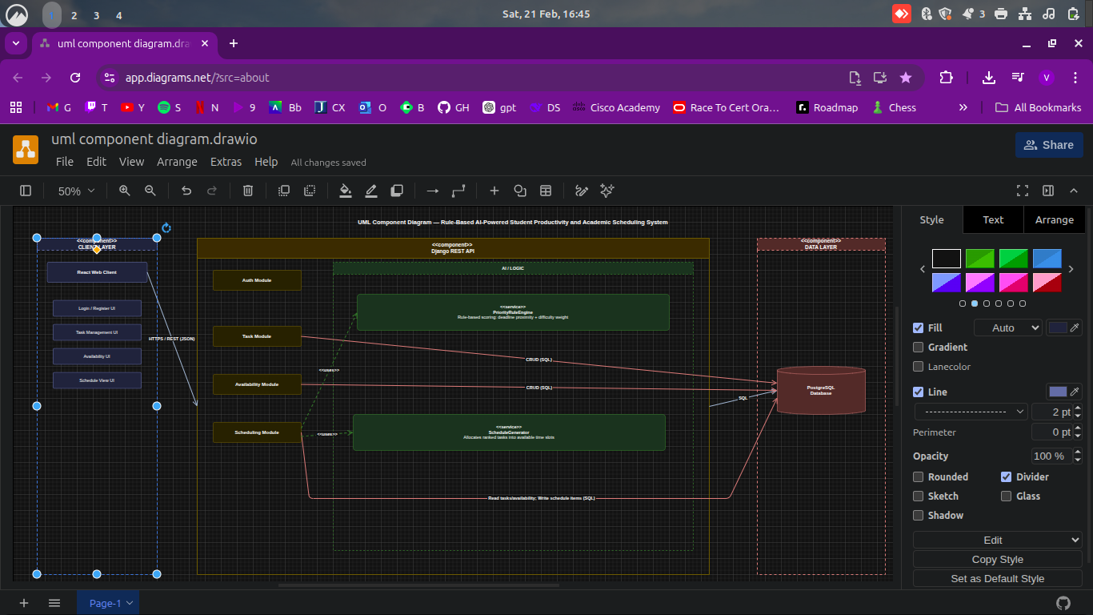
6.
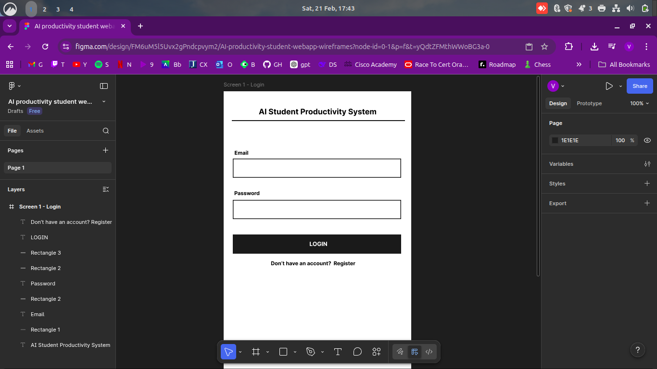
7.
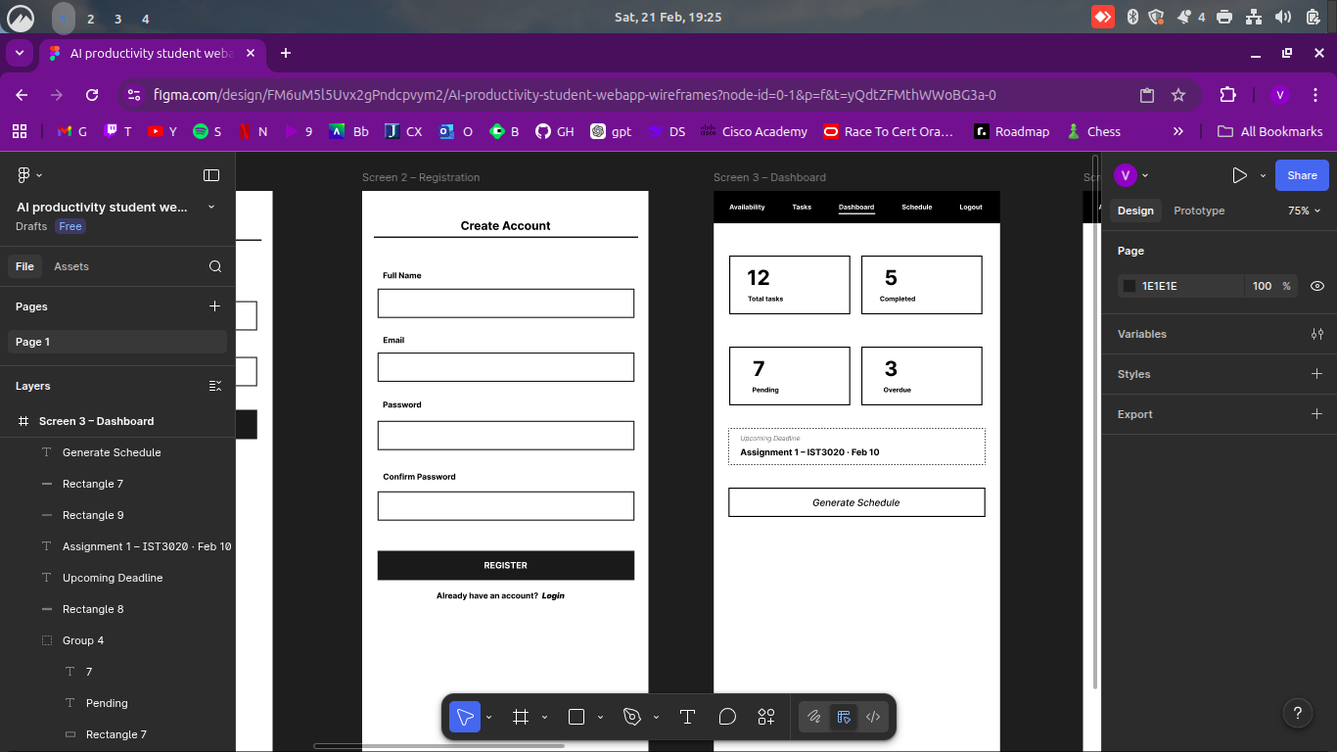
8.
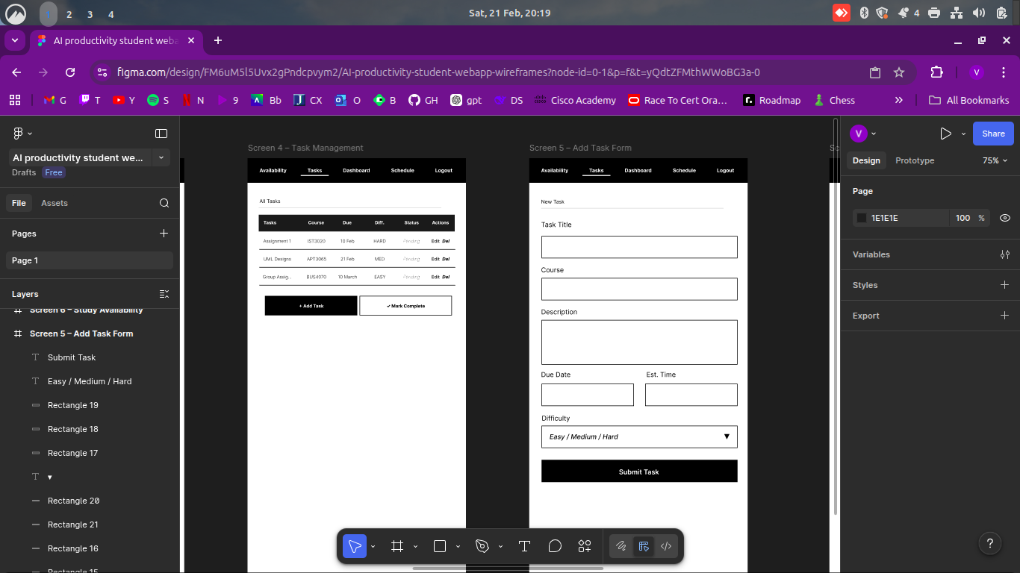
9.
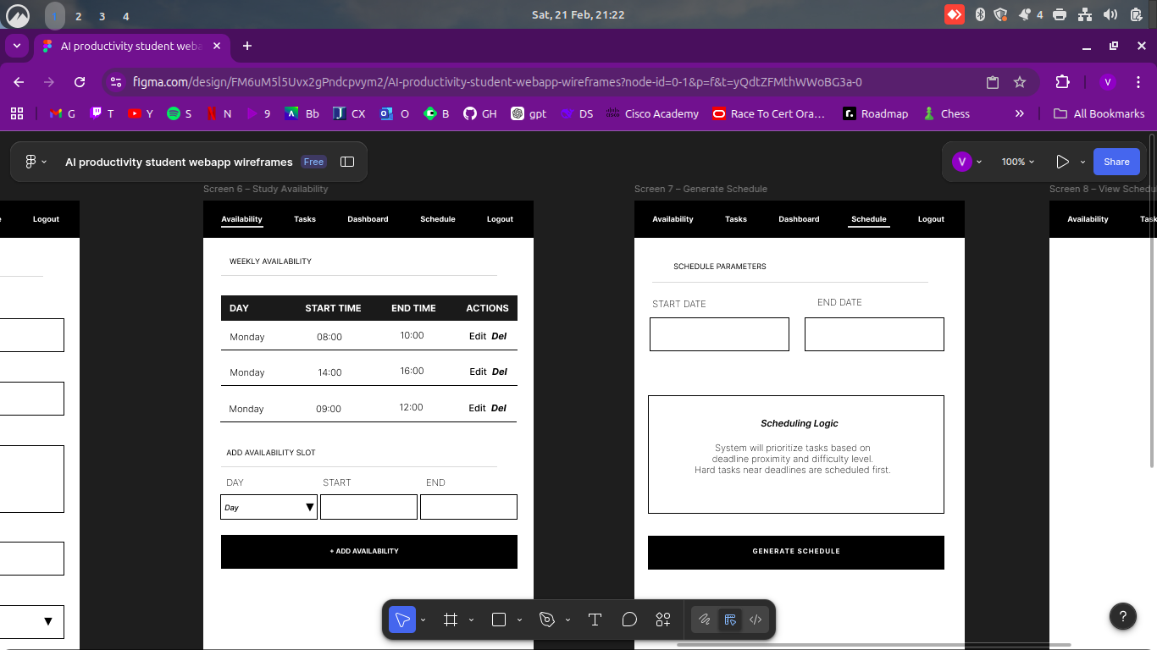
10.
